**2.Git-HOL**

**COMMANDS:**

**Step 1: Create test files and folders**

**cd ~/GitLabPractice**

**1.Creating a .log file and a folder named log:**

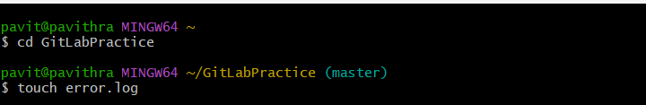

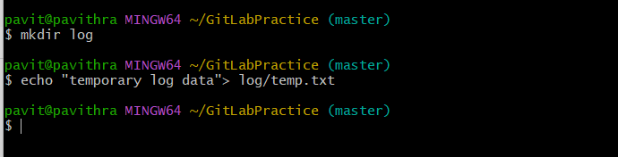

**Step 2: Create and configure .gitignore**

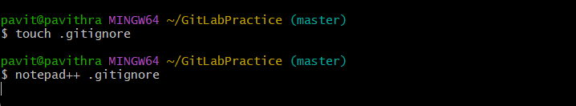

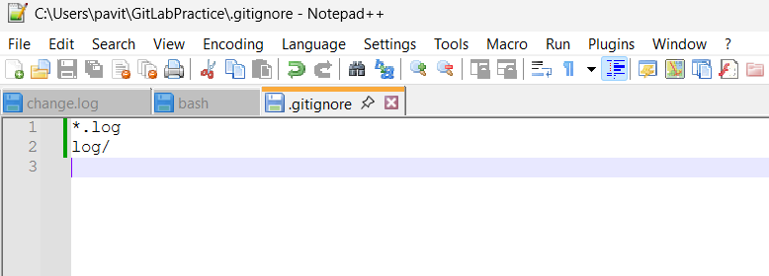

**Step 3: Check Git status**

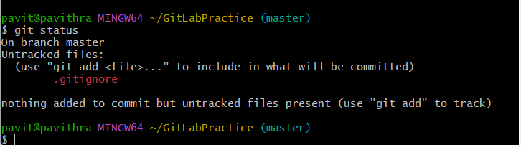

**Step 4: Commit the .gitignore**

